Multiple Linear Regression Assignment

Following the example during the session concerning the Simple Linear Regression model, build a Multiple Linear Regression (MLR) model to predict the CO2 Emissions, using at least 3 quantitative features as inputs. Write the equation of the regression line and evaluate that MLR model using at least 1 regression metric then, compare the result with the one obtained after the Simple Linear Regression evaluation.

Multiple Linear Regression

Step 1. Load Data and Initialize Spark Session
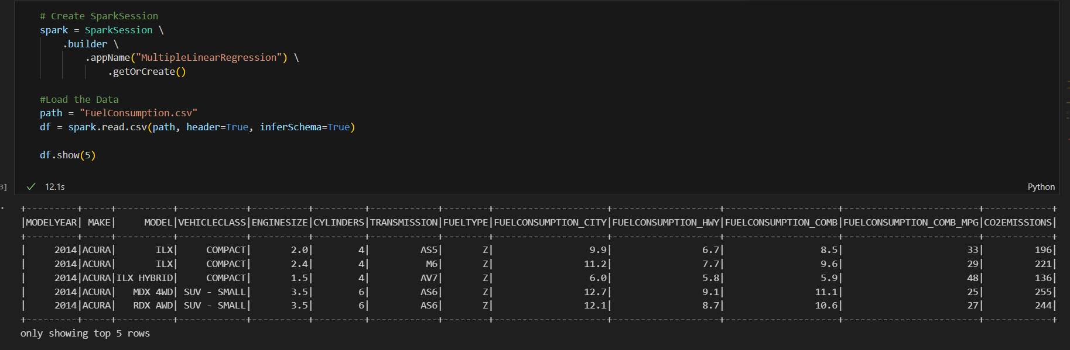
Consider the ENGINESIZE, CYLINDERS and FUELCONSUMPTION_COMB columns as explanatory variables
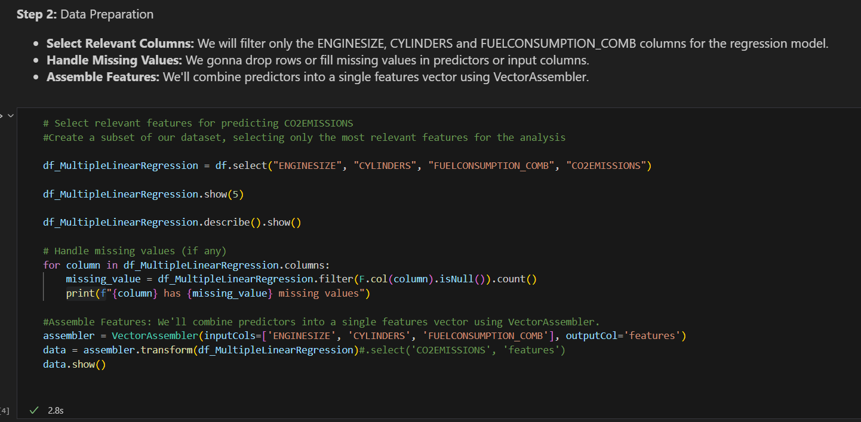
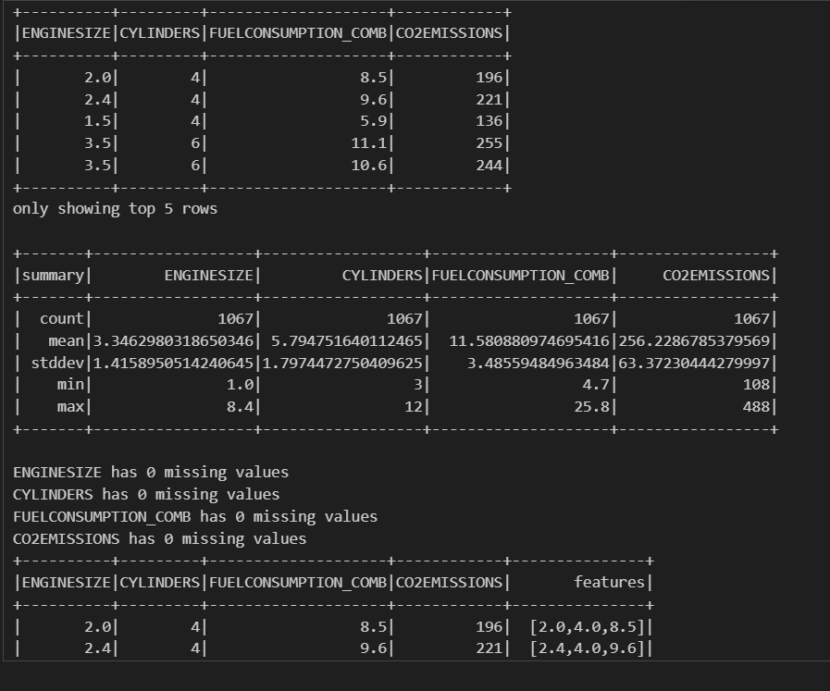
Outputs for this code are:
Now split the data by 80/20% for training and testing
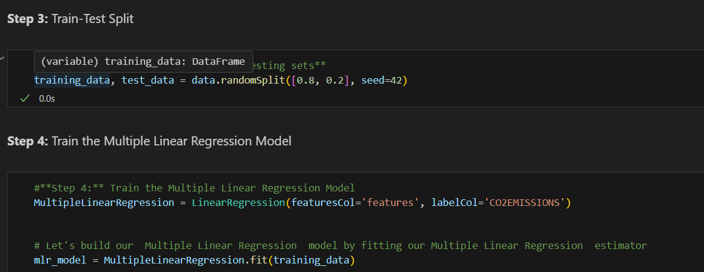
Use the intercept and the different coefficients to write the equation of the multiple regression line of your output feature
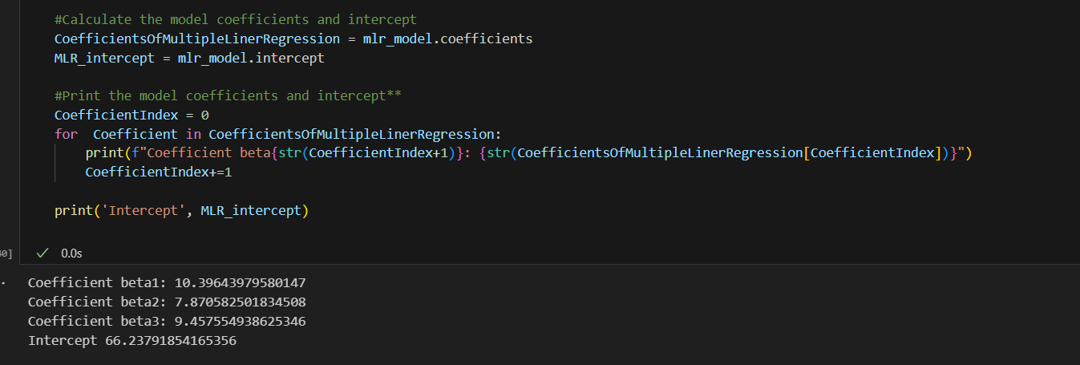
Now use MatPlotLib to express the results graphically
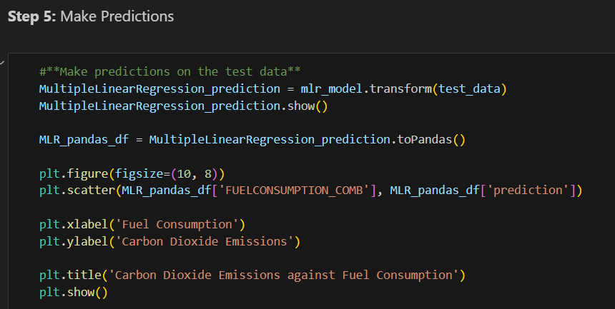
The MatPlotLib code gives the following outputs and graph
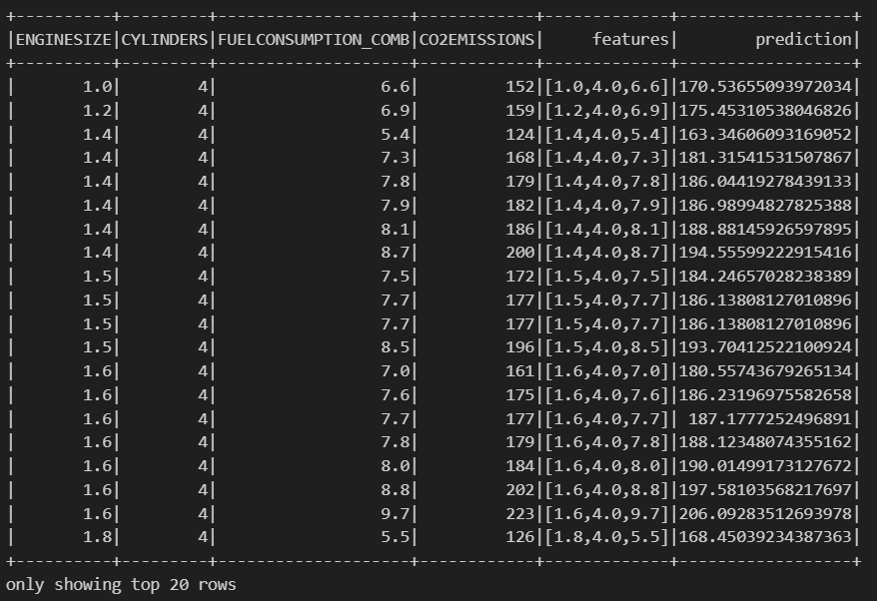
As shown below, the actual Carbon Dioxide Emissions are shown in blue, the MLR model predictions are shown in blue
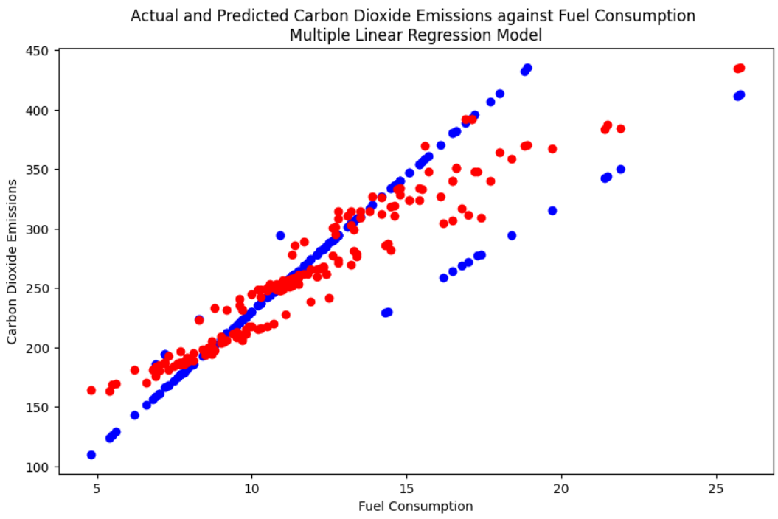

Single Linear Regression: Carbon Dioxide Emissions against Fuel Consumption
By means of contrast with plotting the relationship between Carbon Dioxide Emissions and a three variable Multiple Linear Regression model, the relationship between Carbon Dioxide Emissions and Fuel Consumption was investigated using a Single Linear Regression (SLR) model - using the same method used in the lesson for prediction of the relationship between Carbon Dioxide Emissions and Engine Size.
As shown below, the actual Carbon Dioxide Emissions are shown in blue, the SLR model predictions are shown in green
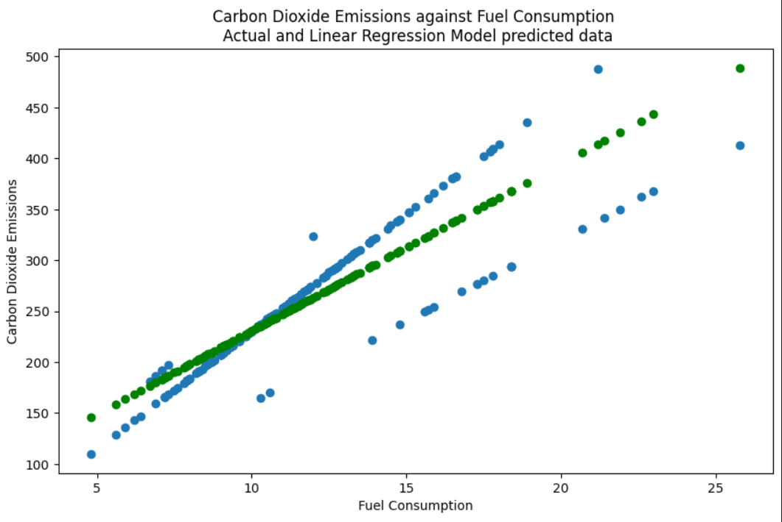
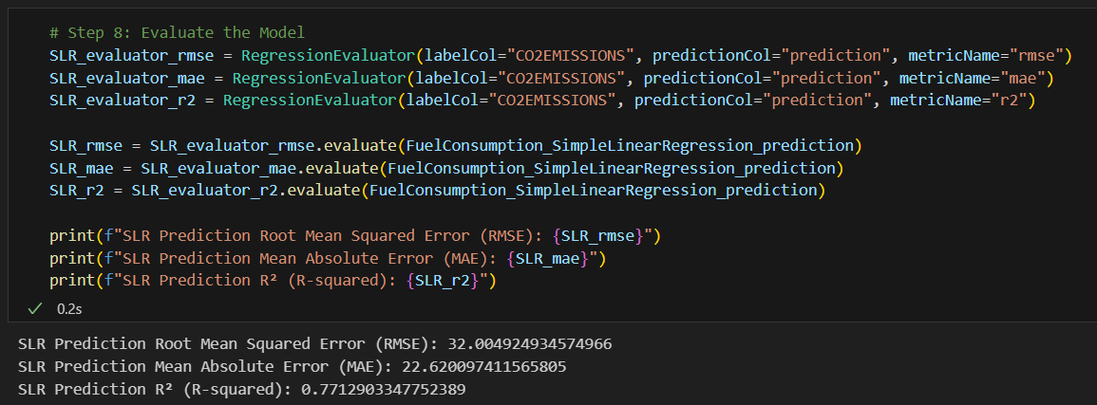

Comparison between evaluation of Multiple and Single Linear Regression model predictions
We can compare Error and R² values for the Multiple and Single Linear Regression model predictions against their original data, to identify that with the smallest errors
Linear Regression Model type  Evaluation metric | Single | Multiple | Improvement of Model Accuracy
Root Mean Squared Error | 32.0 | 24.0 | 25%
Absolute Error | 22.6 | 17.8 | 21%
R² (R-squared) | 0.77 | 0.87 | 13%

By comparing the errors, the Multiple Linear Regression model predictions are, on average, roughly 20-25% more accurate than those of the Single Linear Regression model

